1. Creating Account on Wikipedia

Step 1: To create your account click on create account.

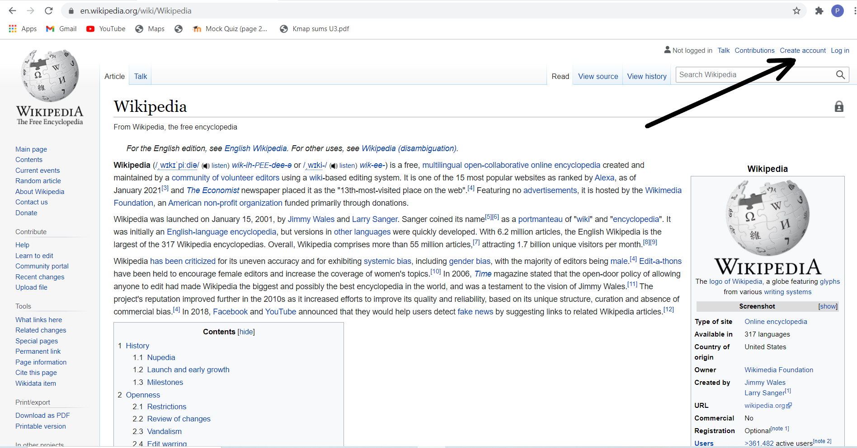

Step 2: Put **Unique** Username Here.

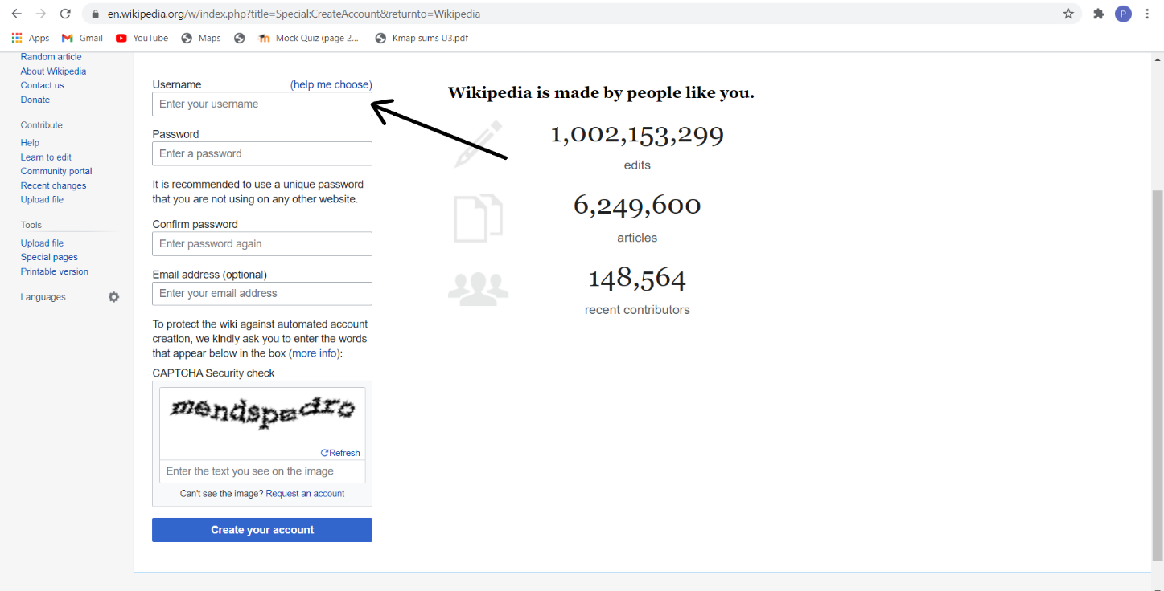

Step 3 : create your password and confirm it once.

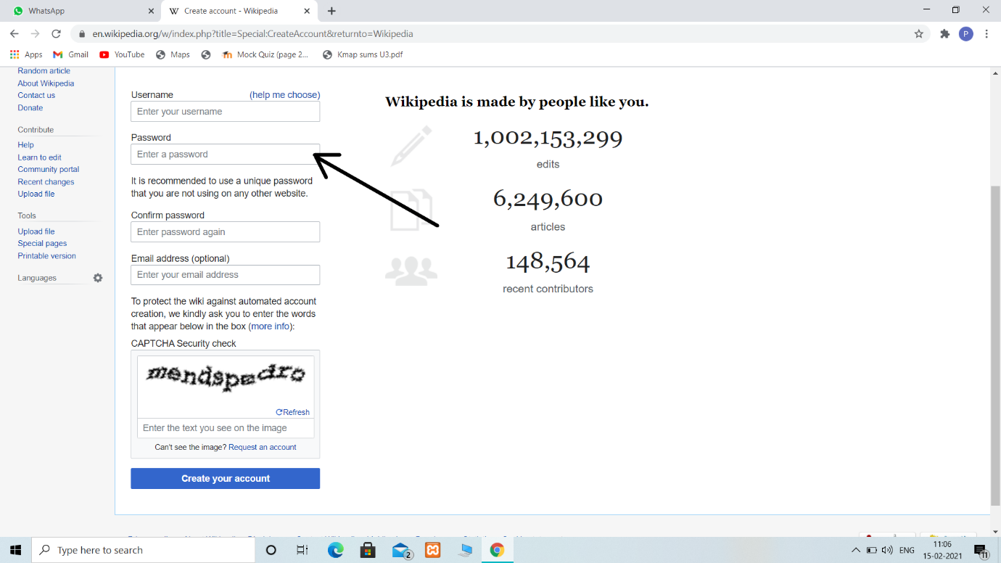

Step 4: Enter same text which is seen in the table

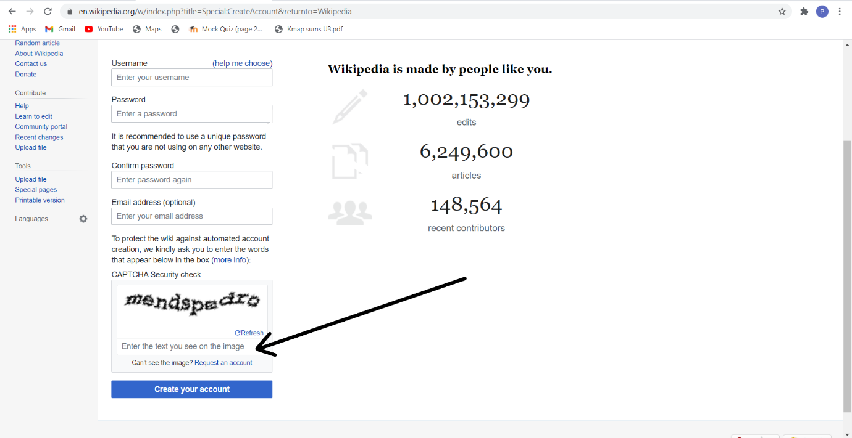

Step 5: click on Create account to create the account.

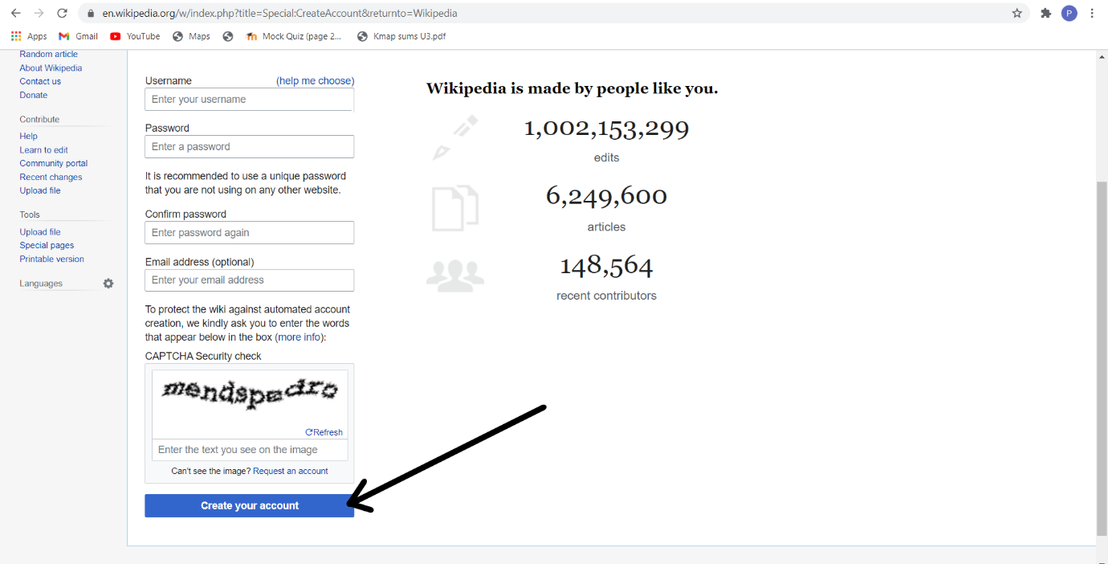

1. Creating your page on Wikipidea

Step 1: Click on view source

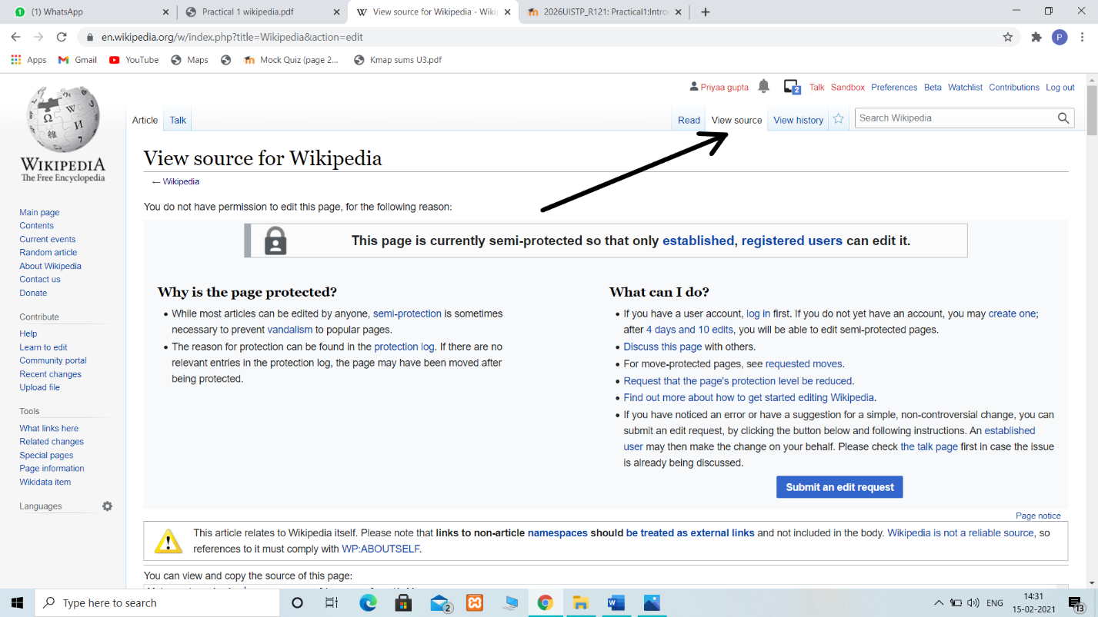

Step 2: Click on Submit an edit request for edit and create a page.

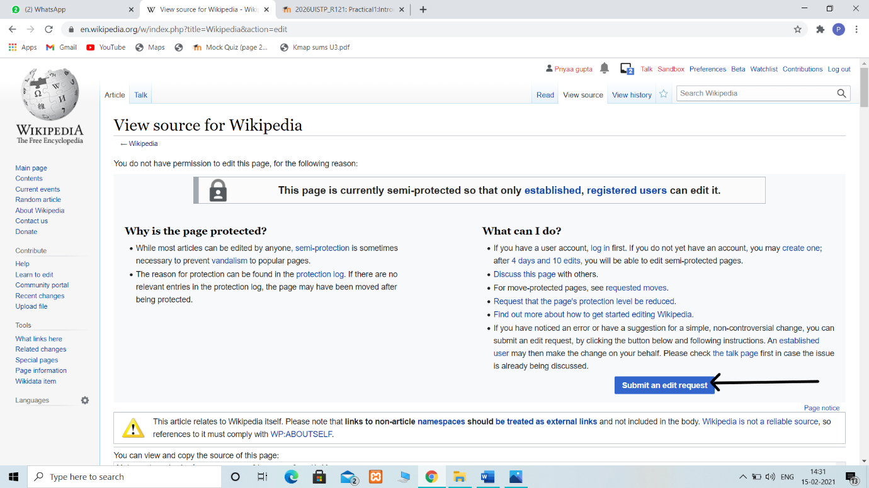

Step 3: Click on New section and here we v=can create our page

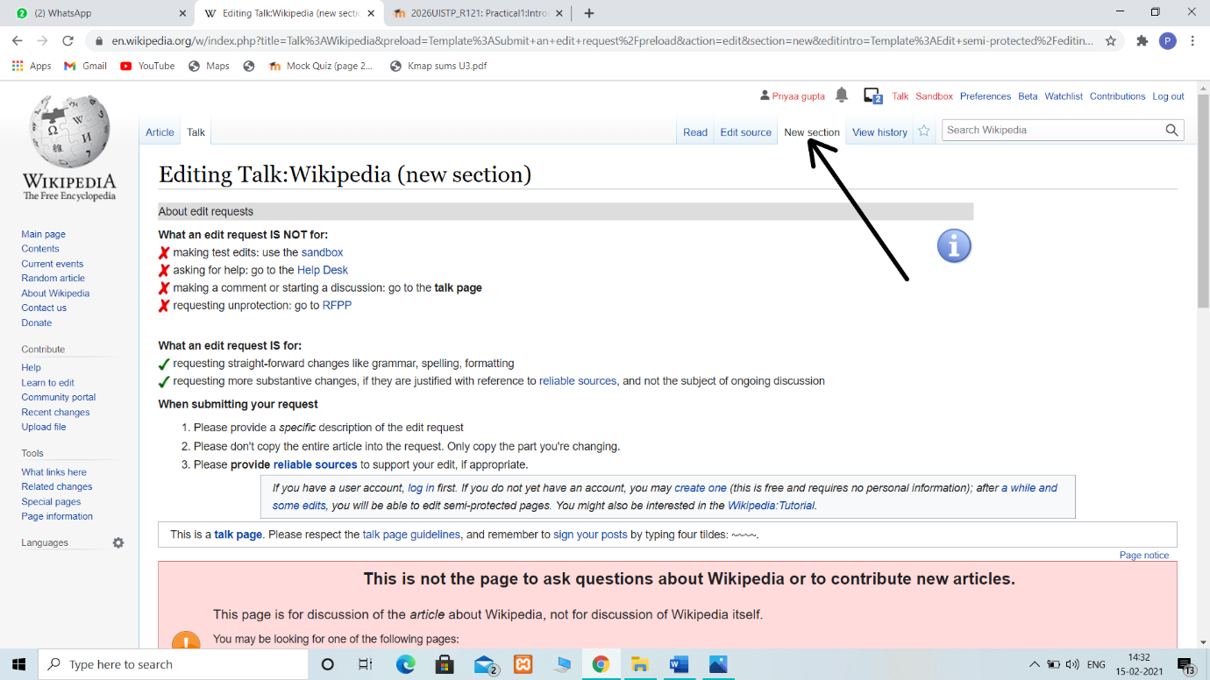

1. Editing your page on Wikipedia

Step 1: Click on Create source button

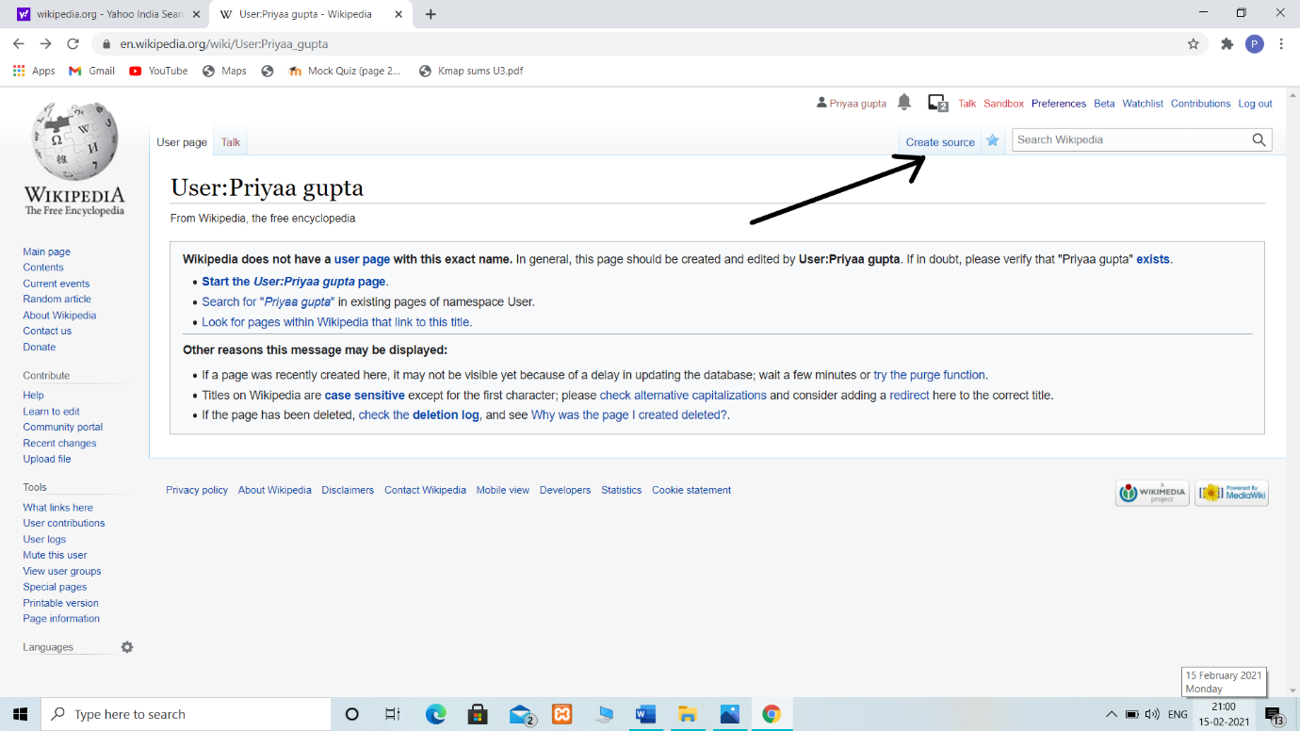

Step 2: Go to the User page and edit your page.

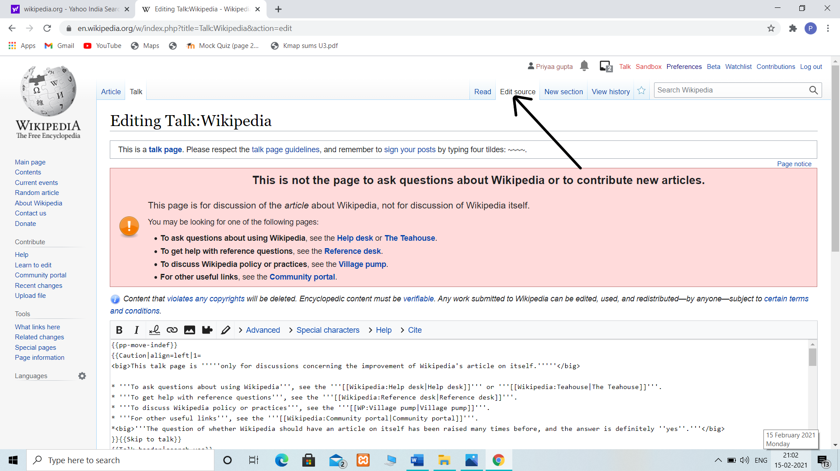

Step 3: By clicking on Publish changes you can Publish your page.

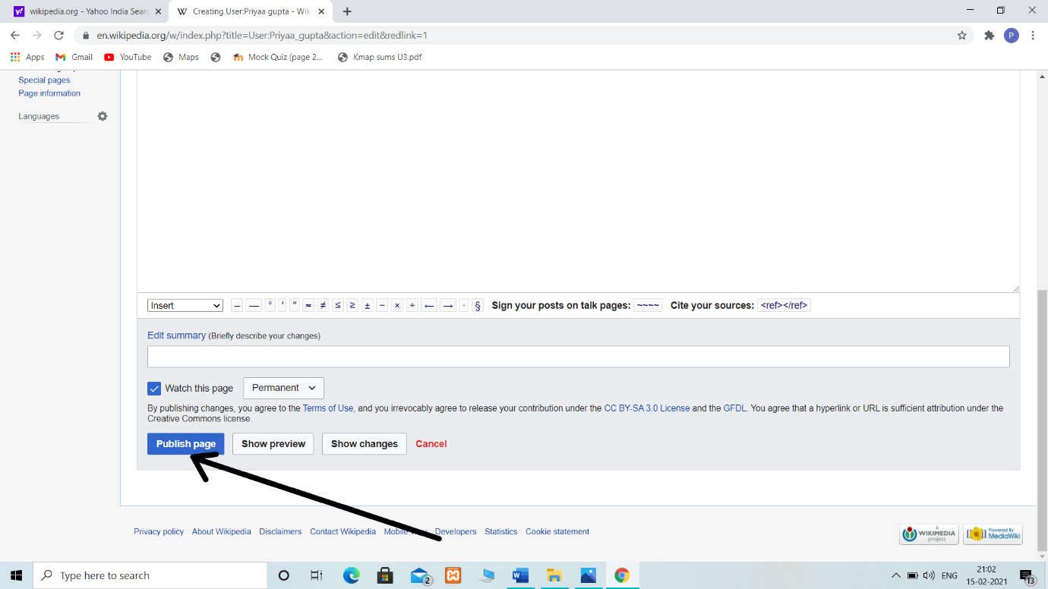

We can read our page by clicking on read.

